**Digital Nurture 4.0 Deep Skilling - Java FSE**  
**WEEK –5 Hands-on Exercises  
Module 8 - Microservices with Spring Boot 3 and Spring Cloud**

**Microservices with API gateway**

1. **Creating Microservices for account and loan**

**AccountFolder**

**AccountController.java**

package com.cognizant.account.controller;

import org.springframework.web.bind.annotation.*;

import java.util.Map;

@RestController

@RequestMapping("/accounts")

public class AccountController {

@GetMapping("/{number}")

public Map<String, Object> getAccount(@PathVariable String number) {

return Map.of(

"number", number,

"type", "savings",

"balance", 234343

);

}

}

**AccountApplication.java**

package com.cognizant.account;

import org.springframework.boot.SpringApplication;

import org.springframework.boot.autoconfigure.SpringBootApplication;

@SpringBootApplication

public class AccountApplication {

public static void main(String[] args) {

SpringApplication.run(AccountApplication.class, args);

}

}

**application.properties**

spring.application.name=account

**AccountApplicationTests.java**

package com.cognizant.account;

import org.junit.jupiter.api.Test;

import org.springframework.boot.test.context.SpringBootTest;

@SpringBootTest

class AccountApplicationTests {

@Test

void contextLoads() {

}

}

**pom.xml**

<?xml version="1.0" encoding="UTF-8"?>

<project xmlns="http://maven.apache.org/POM/4.0.0" xmlns:xsi="http://www.w3.org/2001/XMLSchema-instance"

xsi:schemaLocation="http://maven.apache.org/POM/4.0.0 https://maven.apache.org/xsd/maven-4.0.0.xsd">

<modelVersion>4.0.0</modelVersion>

<parent>

<groupId>org.springframework.boot</groupId>

<artifactId>spring-boot-starter-parent</artifactId>

<version>3.5.3</version>

<relativePath/> <!-- lookup parent from repository -->

</parent>

<groupId>com.cognizant</groupId>

<artifactId>account</artifactId>

<version>0.0.1-SNAPSHOT</version>

<name>account</name>

<description>Spring Boot Microservice for Account</description>

<url/>

<licenses>

<license/>

</licenses>

<developers>

<developer/>

</developers>

<scm>

<connection/>

<developerConnection/>

<tag/>

<url/>

</scm>

<properties>

<java.version>21</java.version>

</properties>

<dependencies>

<dependency>

<groupId>org.springframework.boot</groupId>

<artifactId>spring-boot-starter-web</artifactId>

</dependency>

<dependency>

<groupId>org.springframework.boot</groupId>

<artifactId>spring-boot-devtools</artifactId>

<scope>runtime</scope>

<optional>true</optional>

</dependency>

<dependency>

<groupId>org.springframework.boot</groupId>

<artifactId>spring-boot-starter-test</artifactId>

<scope>test</scope>

</dependency>

</dependencies>

<build>

<plugins>

<plugin>

<groupId>org.springframework.boot</groupId>

<artifactId>spring-boot-maven-plugin</artifactId>

</plugin>

</plugins>

</build>

</project>

**LoanFolder**

**LoanController.java**

package com.cognizant.loan.controller;

import org.springframework.web.bind.annotation.*;

import java.util.Map;

@RestController

@RequestMapping("/loans")

public class LoanController {

@GetMapping("/{number}")

public Map<String, Object> getLoan(@PathVariable String number) {

return Map.of(

"number", number,

"type", "car",

"loan", 400000,

"emi", 3258,

"tenure", 18

);

}

}

**LoanApplication.java**

package com.cognizant.loan;

import org.springframework.boot.SpringApplication;

import org.springframework.boot.autoconfigure.SpringBootApplication;

@SpringBootApplication

public class LoanApplication {

public static void main(String[] args) {

SpringApplication.run(LoanApplication.class, args);

}

}

**application.properties**

spring.application.name=loan

server.port=8081

**LoanApplicationTests.java**

package com.cognizant.loan;

import org.junit.jupiter.api.Test;

import org.springframework.boot.test.context.SpringBootTest;

@SpringBootTest

class LoanApplicationTests {

@Test

void contextLoads() {

}

}

**pom.xml**

<?xml version="1.0" encoding="UTF-8"?>

<project xmlns="http://maven.apache.org/POM/4.0.0" xmlns:xsi="http://www.w3.org/2001/XMLSchema-instance"

xsi:schemaLocation="http://maven.apache.org/POM/4.0.0 https://maven.apache.org/xsd/maven-4.0.0.xsd">

<modelVersion>4.0.0</modelVersion>

<parent>

<groupId>org.springframework.boot</groupId>

<artifactId>spring-boot-starter-parent</artifactId>

<version>3.5.3</version>

<relativePath/> <!-- lookup parent from repository -->

</parent>

<groupId>com.cognizant</groupId>

<artifactId>loan</artifactId>

<version>0.0.1-SNAPSHOT</version>

<name>loan</name>

<description>Spring Boot Microservice for loan</description>

<url/>

<licenses>

<license/>

</licenses>

<developers>

<developer/>

</developers>

<scm>

<connection/>

<developerConnection/>

<tag/>

<url/>

</scm>

<properties>

<java.version>21</java.version>

</properties>

<dependencies>

<dependency>

<groupId>org.springframework.boot</groupId>

<artifactId>spring-boot-starter-web</artifactId>

</dependency>

<dependency>

<groupId>org.springframework.boot</groupId>

<artifactId>spring-boot-devtools</artifactId>

<scope>runtime</scope>

<optional>true</optional>

</dependency>

<dependency>

<groupId>org.springframework.boot</groupId>

<artifactId>spring-boot-starter-test</artifactId>

<scope>test</scope>

</dependency>

</dependencies>

<build>

<plugins>

<plugin>

<groupId>org.springframework.boot</groupId>

<artifactId>spring-boot-maven-plugin</artifactId>

</plugin>

</plugins>

</build>

</project>

**OUTPUT**

**Account.png**

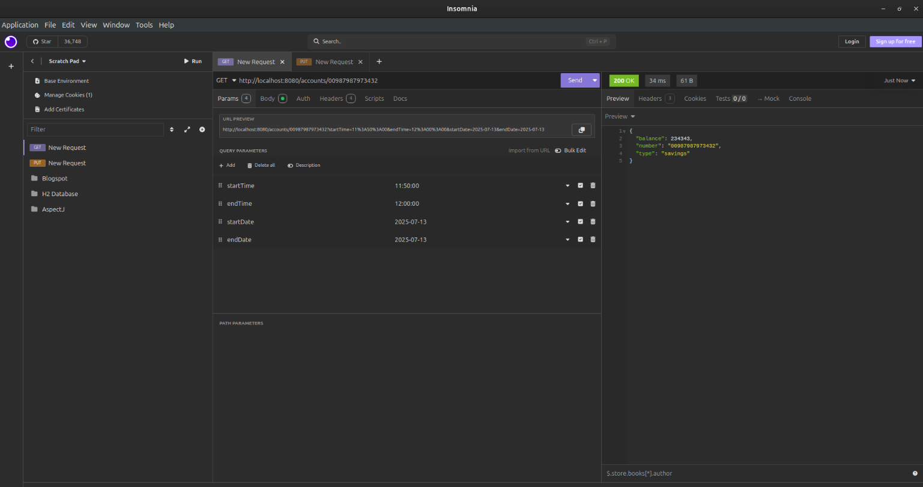

**Loan.png**

